is a senior Media and Information major with a minor in Information Technology. Outside of being a Webmaster for MSU Career Services, she is an advocate for bringing IT opportunities to campus as President and Founder of Leaders in Information Technology. After graduation, Christine is excited to work full time for General Electric in their Information Technology Leadership Program.

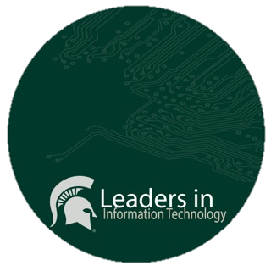

Leaders in Information Technology is a student organization at Michigan State University focused around the IT minor. As a founder, Christine named the organization at this first meeting.